ASSIGNMENT: Managing Data with Lists & Dictionaries

Description
This assignment demonstrates how Python lists and dictionaries can be used to store and manage structured data. Lists store ordered collections of elements while dictionaries store data in key-value pairs. In this program, student records are stored as dictionaries inside a list. The program also demonstrates how to add a new student, modify an existing student’s course, and display all stored records.

Objective
• Understand lists and dictionaries
• Access elements using indexing and keys
• Add, modify, and manage structured data
• Work with nested data structures

Python Code
students = [
{"name": "John", "age": 20, "course": "Computer Science"},
{"name": "Emily", "age": 21, "course": "Data Science"}
]
new_student = {"name": "Michael", "age": 22, "course": "Artificial Intelligence"}
students.append(new_student)
students[0]["course"] = "Software Engineering"
print("Student Records:")
for student in students:
print("Name:", student["name"])
print("Age:", student["age"])
print("Course:", student["course"])
print("-------------------")

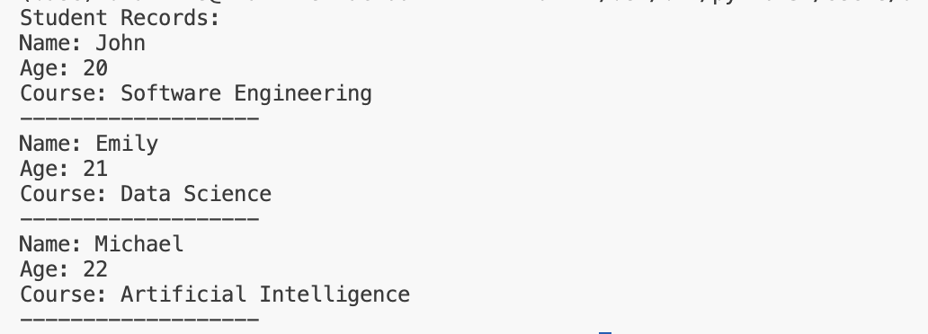

Python Activity & Assignment

ACTIVITY: Lambda Function Practice

Description
Lambda functions in Python are small anonymous functions used for short operations. They are defined using the lambda keyword and can take any number of arguments but contain only one expression. Lambda functions are useful for performing quick calculations without writing a full function definition.

Objective
• Practice lambda syntax
• Perform quick calculations using lambda functions

Python Code
multiply = lambda a, b: a * b
result = multiply(23, 4)
print("Multiplication Result:", result)

